Stock Portfolio Allocation and Risk Management using FinRL/Reinforcement Learning

* **Action rationale**: Why did the RL agent choose a particular asset allocation?
* **Policy interpretation**: What is the strategy or behavior learned by the agent?
* **Risk assessment**: How are risk measures like volatility, Sharpe ratio, and drawdowns being handled?
* **State-action importance**: What market states most influence decisions?

### **. Techniques for Explainability with LLMs**

#### **a. Natural Language Explanations from Logs**

Use LLMs to turn logs from your environment into explanations. For example:

* Track states (market conditions), actions (buy/sell/hold), and rewards.
* Feed sequences into an LLM to generate descriptions:
* Use **SHAP** (SHapley Additive exPlanations) to understand feature contributions for the Q-network or policy network.
* Convert SHAP values into natural language summaries with LLMs

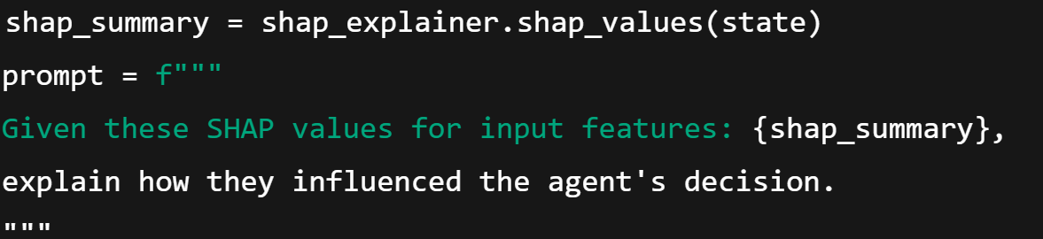

**c. State Clustering + LLM Interpretation**

* Cluster similar states (e.g., bull, bear, volatile).
* Use LLMs to describe agent behavior in each cluster.

**. Visualization + LLM Commentary**

Combine plots (portfolio value, risk metrics, allocation changes) with LLM-generated summaries.

Example: “This dip in the portfolio coincides with increased volatility in the market. The agent responded by reallocating to lower-risk assets.”

### **. Explain Risk Management Policies**

Use LLMs to interpret how your RL agent complies with risk controls:

* Maximum drawdown enforcement
* Portfolio diversification
* Stop-loss triggers

### **. Visualization + LLM Commentary**

* Combine plots (portfolio value, risk metrics, allocation changes) with LLM-generated summaries.
* Example: “This dip in the portfolio coincides with increased volatility in the market. The agent responded by reallocating to lower-risk assets.”

### **. Explain Risk Management Policies**

Use LLMs to interpret how your RL agent complies with risk controls:

* Maximum drawdown enforcement
* Portfolio diversification
* Stop-loss triggers

**LLMs and tools we can combine**

|  |  |
| --- | --- |
| Open Ai GPT-4 | General purpose explainability,financial narrative |
| Gemini | Regulatory compliance and wise decision |
| Meta LlaMa3 | Open source research prototypes |

**References**

* **The properties of equally weighted risk contributions portfolios**. *The Journal of Portfolio Management,* **A Unified Approach to Interpreting Model Predictions**.[SHAP GitHub](https://github.com/slundberg/shap)